**Complex Problem**

In this task imagine you are asked to fill a bag with a set of items, each with its own value and weight. An example of an item is shown in Figure 1 below (if the images do not display, try right-clicking where they should be and opening them in a new tab. If that does not work, you may need to return the study due to technical issues). Inside each dollar note, you will see the value of the item and, below that, its weight.

(Figure 1, an example of an item)

At the centre of the screen, you will be shown the bag's maximum weight capacity (maximum sum of weights allowed in the knapsack). The green outer circle is the countdown timer (see Figure 2 below).

(Figure 2, an example of the maximum weight capacity)

Your aim is to choose the selection of items with the highest possible combined value (sum of item values) while staying within the maximum weight capacity. If the combined weight (sum of item weights) of your selection of items exceeds the maximum weight capacity then that solution is effectively disqualified.  
  
Put differently, you must find the most valuable set of items you can pack into your bag (maximise value) without your bag breaking apart because it's too heavy (staying within the weight capacity). The weight is only relevant to ensure you do not exceed capacity.   
  
Let’s have a look at an example. Below is a screenshot of the task (Figure 3). The explicit question here is: which set of items has the highest combined value, while satisfying that their combined weight is at most 72kg? What do you think the answer is? Give it a try before proceeding to the next page!

 (Figure 3, an example of the problem)

(Figure 4, solution of the example problem)

If you pick the 3 items encircled (see Figure 4 above), you will obtain:  
  
Total Value = $16 + $31 + $38 = $85  
Total Weight = 17kg + 43kg + 7kg = 67kg  
  
In this case, the combination maximises the value without exceeding the weight capacity of 72kg. Any other combination will either: a) give a lower total value; or b) exceed the 72kg weight capacity.  
  
Make sure you understand the rule for solving the problem before continuing.

If you understand the task you can now solve 3 example problems. You have unlimited time and must answer all 3 problems correctly to proceed.  
  
If you answer a problem incorrectly, you will return to the instructions before being able to try again. You have at most 3 attempts to pass. If you fail all three attempts, you will not be able to continue the study.  
  
Click the right arrow button below to proceed to the first practice question, otherwise read the instructions again, and proceed once you are ready.

Which selection of items gives the highest total value without exceeding the weight constraint? You can select multiple items.

Correct answer: Item 1 and item 2

Which selection of items gives the highest total value without exceeding the weight constraint? You can select multiple items.

Correct answer: Item 1, item 2, and item 3

Which selection of items gives the highest total value without exceeding the weight constraint? You can select multiple items.

Correct answer: Item 2 and item 3

In the actual task, you will have the option to click on items to select (or de-select) them. Please use clicking to show your thinking. The moment you think an item is good, click on it to select. The moment you change your mind, click on it again to de-select.  
  
Your final item selection will be those items clicked at the moment of submission.  
  
You will have up to 90 seconds to solve each problem. You will see a green timer at the centre of the screen showing how much time remains.   
  
**If you finish answering the problem before the timer runs out, you can press ENTER on your keyboard to proceed.**  
  
If you don't provide your final answer to the problem after 90 seconds, you will proceed to the next page automatically, and the answer to the problem will be those items selected at the moment when the timer ran out. **Remember, your bonus payment depends only on the number of correctly answered problems. Any incorrect answer will not get you any bonus.   
  
See the video below to see an example of how the task will look, and get ready to answer the questions that follow. (When viewing in MS word, double click to play)**

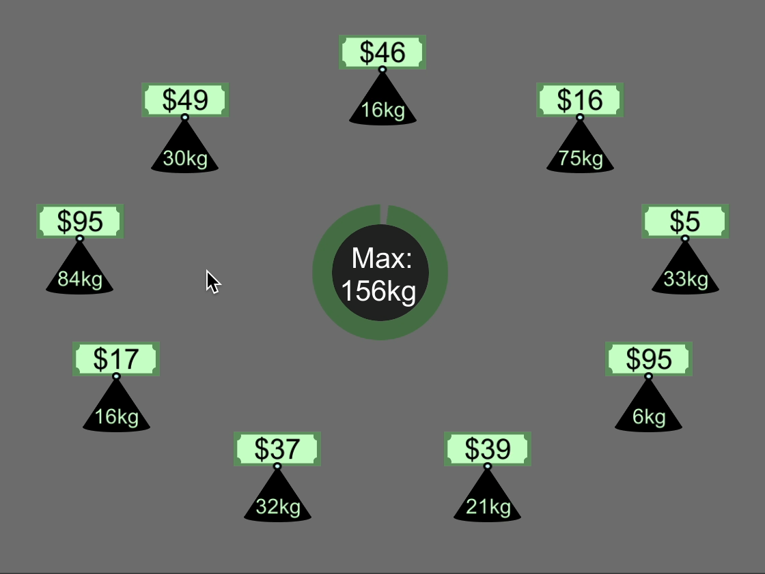

1. In this example video shown what is the maximum weight capacity allowed in the bag (in Kg)?
2. The person solving the problem in the video selected and deselected a few items. In the end, how many items did they have selected?
3. What was the total VALUE of the final selection of items (in $)?
4. What was the total WEIGHT of the final selection of items (in Kg)?
5. If they submitted the final selection of items as their answer, would they get it correct?
6. If they wanted to submit that selection of items as their answer before time ran out (before the green circle disappeared), how could they do that?

Solutions

1. In this example video shown what is the maximum weight capacity allowed in the bag (in Kg)?
   1. 156kg
2. The person solving the problem in the video selected and deselected a few items. In the end, how many items did they have selected?
   1. 3 items
3. What was the total VALUE of the final selection of items (in $)?
   1. $206
4. What was the total WEIGHT of the final selection of items (in Kg)?
   1. 165kg
5. If they submitted the final selection of items as their answer, would they get it correct?
   1. No
6. If they wanted to submit that selection of items as their answer before time ran out (before the green circle disappeared), how could they do that?
   1. Press ENTER